

**NAME:** KASHIF MAJID DAR

**DIVISION:** CS B1

**PRN:** 19070122084

**ASSIGNMENT 4**

# TITLE: Loop Control Structure Objective:

# AIM: 1) Write a program to find whether given number is odd or even. 2) Write a program to find whether given year is leap year or not. 3) Write a program to find whether given number is prime or composite.

**THEORY OF ALGORITHM & FLOWCHART:**

In this programme we use the if[1] and else if selection operators.

The if statement evaluates the test expression inside the parenthesis ().and if the condition is true, it will execute the code inside it.

The else if ladder allows you to check between multiple test expressions and execute different statements.

**ALGORITHM**:

STEP 1 – START

STEP 2 – INPUT A NUMBER ‘A’

STEP 3 –FIND THE MODULUS DIVISION OF THE NUMBER BY 2

STEP 4 – IF IT IS ZERO, PRINT EVEN. ELSE PRINT ODD.

STEP 5 – STOP.

**FLOWCHART:**

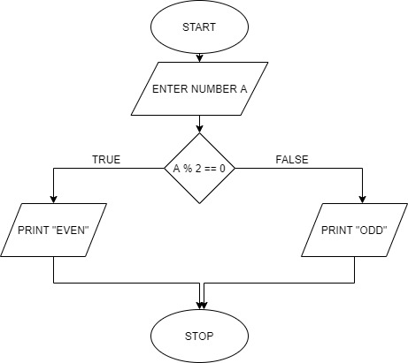

**SOURCE CODE:**

#include<stdio.h>

int main()

{

int num;

printf("Enter an integer: ");

scanf("%d",&num);

if ( num%2 == 0 )

printf("%d is an even number", num);

else

printf("%d is an odd number", num);

return 0;

}

**OUTPUT:**

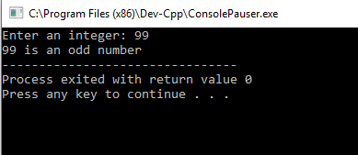

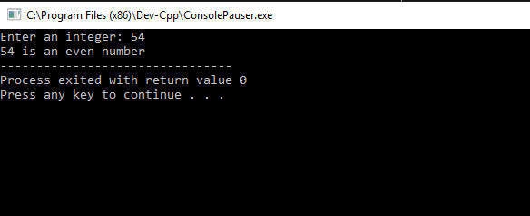

**ALGORITHM**:

STEP 1 – START

STEP 2 – INPUT A NUMBER YEAR

STEP 3 –FIND THE MODULUS DIVISION OF THE NUMBER BY 4

STEP 4 – IF IT IS ZERO, PRINT “LEAP YEAR”. ELSE PRINT NOT A LEAP YEAR.

STEP 5 – STOP

**FLOWCHART:**

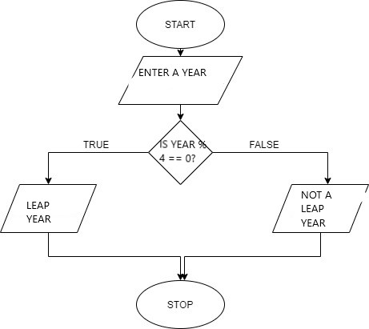

**SOURCE CODE:**

#include <stdio.h>

int main() {

int year;

printf("Enter a year: ");

scanf("%d", &year);

if (year % 4 == 0) {

if (year % 100 == 0) {

if (year % 400 == 0)

printf("%d is a leap year.", year);

else

printf("%d is not a leap year.", year);

} else

printf("%d is a leap year.", year);

} else

printf("%d is not a leap year.", year);

return 0;

}

**OUTPUT:**

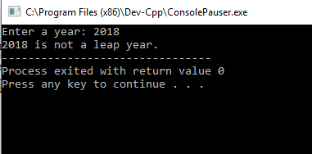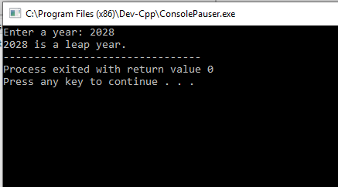

**ALGORITHM**:

STEP 1 – START

STEP 2 – INPUT A NUMBER

STEP 3 – CHECK IF NUMBER IS PRIME USING THE PROGRAM WRITTEN.

STEP 4 – IF IT IS PRIME THEN PRINT NUMBER IS PRIME.

STEP 5 – ELSE PRINT NUMBER IS COMPOSITE.

STEP 6 - STOP

**FLOWCHART:**

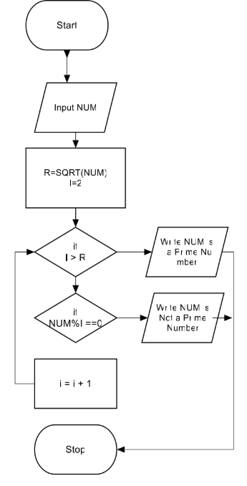

**SOURCE CODE:**

#include<stdio.h>

int main()

{

int i,n,c=0;

printf ("Enter a number \n");

scanf ("%d",&n);

for (i=1; i<=n; i++)

{

if(n%i==0)

c=c+1;

}

if (c==2)

printf ("The number is PRIME");

else

printf ("The number is COMPOSITE");

return 0;

}

**OUTPUT:**

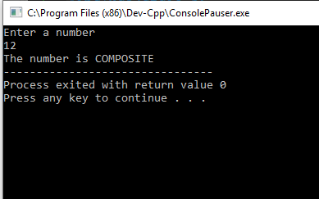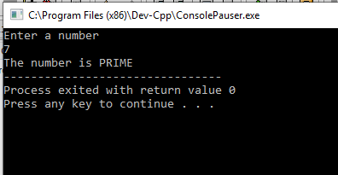

1.